Automated AWS EC2 Cost Optimization System
Objective
This project implements an automated cloud cost optimization system using Amazon Web Services (AWS). The system continuously monitors EC2 CPU utilization using CloudWatch alarms, triggers AWS Lambda functions for automation, calculates EC2 runtime cost using AWS pricing, fetches actual billing data from AWS Cost Explorer, and automatically stops idle EC2 instances to reduce unnecessary cloud expenditure.
Architecture diagram
EC2 Instances
↓
CloudWatch Metrics
↓
CloudWatch Alarms
↓
AWS Lambda Function
↓
────────────────────
Cost Calculation
Runtime Analysis
Cost Explorer Billing
EC2 Stop Automation
────────────────────
↓
Amazon SNS
↓
Email Notification

PROJECT FLOW :
Two EC2 instances were created in the London region (eu-west-2).
Instance Purpose | Instance Type
High CPU Instance | t3.micro
Idle CPU Instance | t3.micro
Two CloudWatch alarms were configured.
HIGH CPU ALARM
Configuration | Value
Metric | CPUUtilization
Threshold | Greater than 70%
Period | 5 minutes
Evaluation Period | 1 datapoint
Action | Trigger Lambda
Purpose:
- Detects high workload/activity
- Sends notification report
- Does not stop the instance

IDLE CPU ALARM
Configuration | Value
Metric | CPUUtilization
Threshold | Less than 5%
Period | 5 minutes
Evaluation Periods | 2 datapoints
Datapoints to Alarm | 2 out of 2
Missing Data Treatment | Treat missing data as good
Action | Trigger Lambda
Purpose:
- Detects continuously idle EC2 instances
- Prevents temporary CPU drops from triggering optimization
- Automatically stops unused resources
- Calculates cost savings
- Sends optimization report
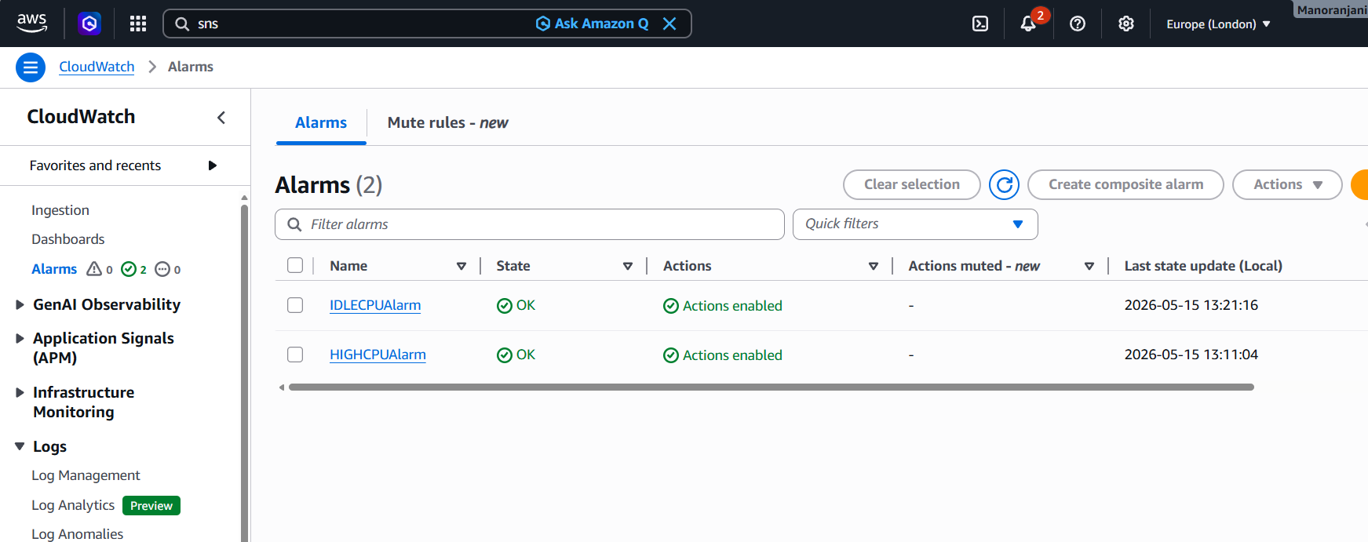

Created Lambda function
CostOptimizationfunction
Runtime : Python 3.12

Created SNS topic
Amazon SNS was used for email notifications
The Lambda execution role was assigned the following managed policies:
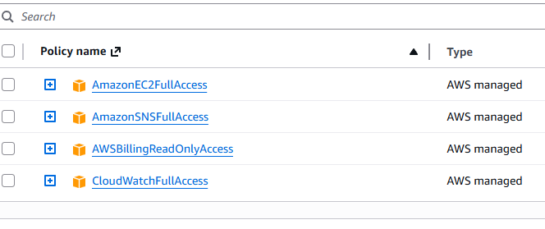

HIGHCPU WORKFLOW
EC2 CPU > 70%
↓
CloudWatch Alarm Triggered
↓
Lambda Invoked
↓
Runtime Cost Calculated
↓
Cost Explorer Billing Retrieved
↓
SNS Email Notification Sent

IDLE CPU WORKFLOW
EC2 Instance Running
↓
CloudWatch Monitors CPU Every 5 Minutes
↓
CPU Remains Below 5%
for 2 Consecutive Datapoints
(~10 Continuous Minutes)
↓
CloudWatch Alarm Triggered
↓
Lambda Invoked
↓
Lambda Validates Instance Runtime
(Runtime Must Be Greater Than 5 Minutes)
↓
Runtime Cost Calculated
↓
Cost Explorer Billing Retrieved
↓
Idle EC2 Automatically Stopped
↓
Savings Calculated
↓
SNS Optimization Report Sent

AWS EC2 PRICING :
Region: London (eu-west-2)
Instance Type: t3.micro
Approximate AWS On-Demand Linux Pricing:
$0.0118/hour
RUNTIME COST FORMULA :
Estimated Runtime Cost = Hourly Price × (Runtime Minutes / 60)
Example:
0.0118 × (68.87 / 60)
≈ $0.013545

SAVINGS CALCULATION FORMULA:
Estimated Savings = Daily Cost − Runtime Cost
Daily Cost:
0.0118 × 24
≈ $0.2832/day
Run time : 6.17 min
Runtime cost :0.0118 × (6.17/60)
=$0.001214
Example:
0.2832 − 0.001214
≈ $0.281986/day

COST EXPLORER INTEGRATION:
AWS Cost Explorer API was integrated to retrieve actual AWS billing information.
Cost Explorer values may appear extremely small because:
- Free Tier credits may apply
- Billing updates are delayed
- EC2 runtime duration is short
- AWS billing data is aggregated account-wide

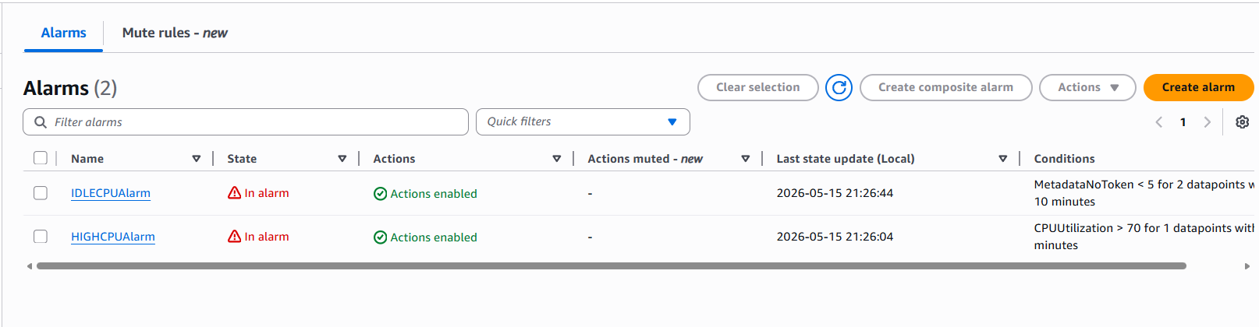

OUTPUT:
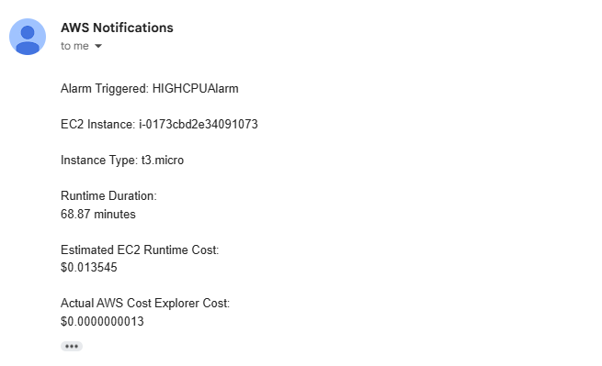
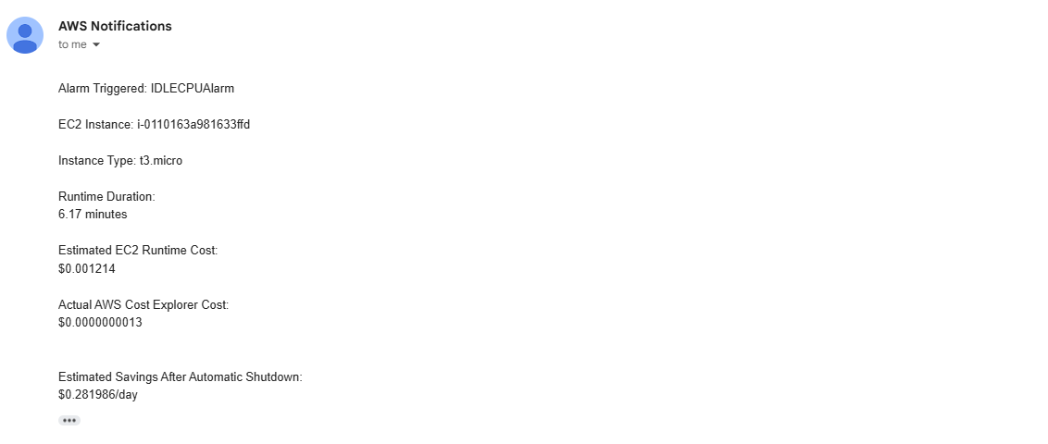

AWS Cost explorer API Status:
Billing data received successfully
(Current processed account cost may be delayed due to AWS billing updates)
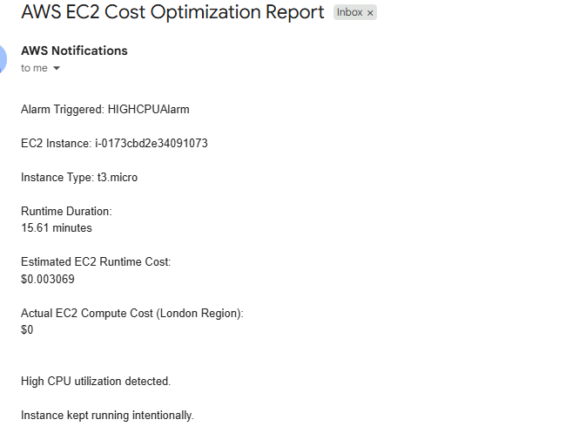

LAMBDA PYTHON CODE :
import json
import boto3
from datetime import datetime, timedelta

# AWS Clients
ec2 = boto3.client('ec2')
sns = boto3.client('sns')
ce = boto3.client('ce')

# SNS Topic ARN
SNS_TOPIC_ARN = 'arn:aws:sns:eu-west-2:195714075112:cost-optimization-topic'

# EC2 Pricing (London eu-west-2)
INSTANCE_PRICING = {
't3.micro': 0.0118
}

def lambda_handler(event, context):

print("Received Event:")
print(json.dumps(event))

# Alarm Name
alarm_name = event['alarmData']['alarmName']

# Instance ID from CloudWatch Alarm Event
instance_id = event['alarmData']['configuration']['metrics'][0]['metricStat']['metric']['dimensions']['InstanceId']

print("Alarm Name:", alarm_name)
print("Instance ID:", instance_id)

# Get EC2 Instance Details
instance_info = ec2.describe_instances(
InstanceIds=[instance_id]
)

instance = instance_info['Reservations'][0]['Instances'][0]

instance_type = instance['InstanceType']

launch_time = instance['LaunchTime']

print("Instance Type:", instance_type)
print("Launch Time:", str(launch_time))

# Calculate Runtime Duration
current_time = datetime.utcnow().replace(tzinfo=launch_time.tzinfo)

runtime = current_time - launch_time

runtime_minutes = runtime.total_seconds() / 60

# Pricing Calculation
hourly_price = INSTANCE_PRICING.get(instance_type, 0)

estimated_runtime_cost = hourly_price * (runtime_minutes / 60)

daily_cost = hourly_price * 24

estimated_savings = daily_cost - estimated_runtime_cost

# Cost Explorer (Actual AWS Billing)
try:

today = datetime.utcnow().date()

yesterday = today - timedelta(days=1)

cost_response = ce.get_cost_and_usage(
TimePeriod={
'Start': str(yesterday),
'End': str(today)
},
Granularity='DAILY',
Metrics=['UnblendedCost']
)

actual_cost = cost_response['ResultsByTime'][0]['Total']['UnblendedCost']['Amount']

except Exception as e:

print("Cost Explorer Error:", str(e))

actual_cost = "0.0"

# Common Email Message
message = f"""
Alarm Triggered: {alarm_name}

EC2 Instance: {instance_id}

Instance Type: {instance_type}

Runtime Duration:
{runtime_minutes:.2f} minutes

Estimated EC2 Runtime Cost:
${estimated_runtime_cost:.6f}

Actual AWS Cost Explorer Cost:
${actual_cost}
"""

# IDLE CPU Logic
if 'IDLE' in alarm_name.upper():

ec2.stop_instances(
InstanceIds=[instance_id]
)

message += f"""

Estimated Savings After Automatic Shutdown:
${estimated_savings:.6f}/day

Idle EC2 instance stopped successfully.
"""

# HIGH CPU Logic
elif 'HIGH' in alarm_name.upper():

message += """

High CPU utilization detected.

Instance kept running intentionally.
"""

# Send SNS Email
sns.publish(
TopicArn=SNS_TOPIC_ARN,
Subject='AWS EC2 Cost Optimization Report',
Message=message
)

print("SNS Email Sent Successfully")

return {
'statusCode': 200,
'body': json.dumps('Success')
}

import json
import boto3
from datetime import datetime, timedelta

# AWS Clients
ec2 = boto3.client('ec2')
sns = boto3.client('sns')
ce = boto3.client('ce')

# SNS Topic ARN
SNS_TOPIC_ARN = 'arn:aws:sns:eu-west-2:195714075112:cost-optimization-topic'

# EC2 Pricing (London Region - eu-west-2)
INSTANCE_PRICING = {
't3.micro': 0.0118
}

def lambda_handler(event, context):

print("Received Event:")
print(json.dumps(event))

# Alarm Name
alarm_name = event['alarmData']['alarmName']

# Extract Instance ID dynamically
instance_id = event['alarmData']['configuration']['metrics'][0]['metricStat']['metric']['dimensions']['InstanceId']

print("Alarm Name:", alarm_name)
print("Instance ID:", instance_id)

# Get EC2 Instance Details
response = ec2.describe_instances(
InstanceIds=[instance_id]
)

instance = response['Reservations'][0]['Instances'][0]

instance_type = instance['InstanceType']

launch_time = instance['LaunchTime']

print("Instance Type:", instance_type)
print("Launch Time:", str(launch_time))

# Calculate Runtime
current_time = datetime.utcnow().replace(tzinfo=launch_time.tzinfo)

runtime = current_time - launch_time

runtime_minutes = runtime.total_seconds() / 60

print("Runtime Minutes:", runtime_minutes)

# EC2 Pricing Calculation
hourly_price = INSTANCE_PRICING.get(instance_type, 0)

estimated_runtime_cost = hourly_price * (runtime_minutes / 60)

daily_cost = hourly_price * 24

estimated_savings = max(daily_cost - estimated_runtime_cost, 0)

# AWS Cost Explorer (EC2 Cost - London Region Only)
try:

today = datetime.utcnow().date()

yesterday = today - timedelta(days=1)

cost_response = ce.get_cost_and_usage(
TimePeriod={
'Start': str(yesterday),
'End': str(today)
},
Granularity='DAILY',
Metrics=['UnblendedCost'],
Filter={
'And': [
{
'Dimensions': {
'Key': 'SERVICE',
'Values': ['Amazon Elastic Compute Cloud - Compute']
}
},
{
'Dimensions': {
'Key': 'REGION',
'Values': ['EU (London)']
}
}
]
}
)

actual_cost = cost_response['ResultsByTime'][0]['Total']['UnblendedCost']['Amount']

except Exception as e:

print("Cost Explorer Error:", str(e))

actual_cost = "0.0"

# Common Email Content
message = f"""
Alarm Triggered: {alarm_name}

EC2 Instance: {instance_id}

Instance Type: {instance_type}

Runtime Duration:
{runtime_minutes:.2f} minutes

Estimated EC2 Runtime Cost:
${estimated_runtime_cost:.6f}

Actual EC2 Compute Cost (London Region):
${actual_cost}
"""

# IDLE CPU LOGIC
if 'IDLE' in alarm_name.upper():

# Ensure instance has actually run for at least 5 minutes
if runtime_minutes < 5:

message += """

Instance runtime below 5 minutes.

Skipping automatic shutdown.
"""

sns.publish(
TopicArn=SNS_TOPIC_ARN,
Subject='AWS EC2 Idle Check Report',
Message=message
)

print("Instance runtime below 5 minutes.")
print("Skipping shutdown.")

return {
'statusCode': 200,
'body': json.dumps('Skipped shutdown')
}

# Stop Idle EC2 Instance
ec2.stop_instances(
InstanceIds=[instance_id]
)

message += f"""

Estimated Savings After Automatic Shutdown:
${estimated_savings:.6f}/day

Idle EC2 instance stopped successfully.
"""

# HIGH CPU LOGIC
elif 'HIGH' in alarm_name.upper():

message += """

High CPU utilization detected.

Instance kept running intentionally.
"""

# Send SNS Notification
sns.publish(
TopicArn=SNS_TOPIC_ARN,
Subject='AWS EC2 Cost Optimization Report',
Message=message
)

print("SNS Email Sent Successfully")

return {
'statusCode': 200,
'body': json.dumps('Success')
}

